

Online Auction System with Real-Time Bidding
Submitted in the partial fulfilment for the Course of
CSA1016- Software Engineering
to the award of the degree of
BACHELOR OF ENGINEERING
IN
Artificial Intelligence and Data Science
Submitted by
Akileshwaran A(192511354)
Under the Supervision of
Dr C Anita Davamani

SIMATS ENGINEERING
Saveetha Institute of Medical and Technical Sciences
Chennai-602105




Table of Contents

1 | Executive Summary
2 | Industry Context
3 | Problem Statement
4 | Existing System
5 | Proposed System
6 | System Architecture
7 | Project Management & UI Screenshots
8 | Objectives
9 | Functional Requirements
10 | Non-Functional Requirements
11 | Use Case Descriptions
12 | Data Requirements
13 | Requirement Prioritization (MoSCoW)
14 | Future Enhancements
15 | Conclusion

1. Executive Summary
The Online Auction System with Real-Time Bidding is a web-based application designed to modernize the traditional auction process by allowing buyers and sellers to participate in auctions from any location through the Internet. Unlike conventional auctions that require participants to be physically present, this system enables users to bid on products online with instant bid updates. Every new bid is reflected immediately, ensuring a fair, transparent, and competitive auction environment.
The primary objective of the proposed system is to provide a secure, efficient, and user-friendly platform for conducting online auctions. The system allows sellers to create auction listings by providing product details such as title, description, category, images, starting price, reserve price, and auction duration. Buyers can browse available products, participate in live auctions, monitor bid progress, and place higher bids in real time until the auction ends.
The system consists of three major users: Administrator, Seller, and Buyer. The administrator is responsible for managing users, approving auction listings, monitoring bidding activities, handling complaints, and generating reports. Sellers can upload products, schedule auctions, and view auction results. Buyers can register, log in, search for products, place bids, receive notifications, and complete payments after winning an auction.
One of the key features of the proposed system is Real-Time Bidding, where the latest bid is displayed instantly to all participants without requiring page refreshes. This increases transparency and eliminates delays that may occur in traditional online auction systems. Automatic winner selection is performed when the auction timer expires, ensuring that the highest bidder is declared the winner.
The application also incorporates strong security measures such as secure user authentication, encrypted passwords, role-based access control, and protected payment processing. Notifications are sent to users regarding auction status, bid updates, auction completion, and payment confirmation. The system stores all auction information, bidding history, transaction details, and user records in a centralized database for future reference.
Overall, the Online Auction System with Real-Time Bidding offers a reliable, transparent, and efficient solution for conducting online auctions. It improves accessibility, reduces manual effort, minimizes fraud, and provides a seamless digital experience for buyers, sellers, and administrators. The proposed system can be applied in various domains such as electronics, vehicles, antiques, artwork, collectibles, and government auctions, making it a scalable and practical solution for modern e-commerce platforms.

2. Industry Context

With the rapid growth of digital technologies and e-commerce, online marketplaces have become an important part of modern business. Customers now prefer online platforms because they offer convenience, faster transactions, and access to products from different locations. Online auction systems are increasingly being used to sell electronics, antiques, artwork, vehicles, collectibles, real estate, and many other valuable items.
Traditional auction methods often require participants to gather at a physical location, making the process time-consuming and expensive. They also limit participation to people who can attend in person. Online auction systems overcome these limitations by allowing users to participate from anywhere using computers or smartphones. The introduction of real-time bidding technology further improves the auction process by displaying bid updates instantly, ensuring fairness and encouraging active participation.
Businesses benefit from online auctions because they attract more buyers, increase competition among bidders, and often result in higher selling prices. Customers benefit from a transparent system where all bids are visible in real time, reducing the chances of unfair practices. The increasing use of secure payment gateways, cloud computing, and web technologies has made online auction platforms more reliable and scalable.
As digital commerce continues to grow, online auction systems are becoming an essential component of modern e-commerce, providing secure, efficient, and user-friendly services for buyers, sellers, and administrators.

3. Problem Statement
Traditional auction systems face several challenges that reduce efficiency and user satisfaction. Physical auctions require buyers and sellers to be present at a specific location and time, making participation difficult for people living in different regions. Manual bidding also increases the possibility of human errors, delays, and misunderstandings during the auction process.
Many existing online auction platforms do not provide real-time bid updates, causing delays between placing and displaying bids. This can create confusion among participants and reduce trust in the auction process. Some systems also lack proper security mechanisms, making them vulnerable to unauthorized access, fake bidding, and fraudulent transactions.
Managing auctions manually requires significant effort from administrators, including verifying users, monitoring bidding activities, resolving disputes, and maintaining auction records. Without proper automation, these tasks become time-consuming and inefficient. Additionally, users may not receive timely notifications about auction status, leading to missed bidding opportunities.
Therefore, there is a need for a secure, automated, and real-time online auction system that provides instant bid updates, transparent bidding, secure payment processing, efficient administration, and an improved user experience.

4. Existing System
The existing online auction systems provide basic functionality for listing products and allowing users to place bids through the internet. Most systems include user registration, login, product browsing, and auction participation. Some platforms also provide payment integration and order tracking. While these features support online auctions, many existing systems still have several limitations that affect their overall performance and user satisfaction.
In many cases, bid updates are not displayed immediately, causing delays that reduce transparency and fairness. Some systems require users to refresh the webpage manually to view the latest bids. Security is another concern, as weak authentication methods and insufficient data protection increase the risk of unauthorized access and fraudulent activities.
Existing systems also provide limited notification services, making it difficult for users to track auction progress. Administrators often spend considerable time managing auctions manually, verifying users, resolving conflicts, and maintaining records. As the number of users increases, these systems may experience performance issues due to limited scalability.
Although existing platforms have introduced online auction capabilities, there remains significant scope for improvement through real-time bidding, stronger security, automated winner selection, efficient administration, and better user interaction. These limitations motivate the development of the proposed Online Auction System with Real-Time Bidding.

5. Proposed System
The proposed Online Auction System with Real-Time Bidding is designed to overcome the limitations of traditional and existing online auction platforms by providing a secure, transparent, and efficient environment for conducting auctions. The system allows buyers and sellers to participate in auctions from anywhere using an internet connection. By integrating real-time communication technology, every bid placed by a user is updated instantly on all connected devices, ensuring that all participants have equal access to the latest bidding information.
The system consists of three major modules: Buyer, Seller, and Administrator. Buyers can register, log in, browse auction items, participate in live bidding, receive notifications, and make secure payments after winning an auction. Sellers can create auction listings, upload product images, set the starting price, define auction duration, and monitor bidding activities. The administrator manages user accounts, verifies auction listings, monitors bidding activities, resolves disputes, and generates reports.
One of the key features of the proposed system is the real-time bidding mechanism, which updates the highest bid immediately without requiring users to refresh the webpage. This feature increases transparency, prevents confusion, and enhances user trust. The system automatically identifies the highest bidder when the auction ends and declares the winner. Secure payment integration allows winners to complete transactions safely, while automated notifications keep users informed about auction status, outbid alerts, auction completion, and payment confirmation.
The system also maintains a centralized database containing user details, auction information, bidding history, payment records, and transaction logs. Strong authentication, encrypted passwords, and role-based access control improve security and protect user data. Overall, the proposed system provides a modern, scalable, and user-friendly solution that simplifies auction management and improves the overall auction experience.

6. System Architecture
The system architecture of the Online Auction System with Real-Time Bidding is designed to ensure efficient communication between users, the application server, and the database. It follows a client-server architecture where buyers, sellers, and administrators access the application through a web browser or mobile device.
The User Layer consists of buyers and sellers who interact with the system by registering, logging in, browsing products, creating auctions, and placing bids. All user requests are processed by the application server.
The Application Layer handles business logic, including user authentication, auction management, bid validation, payment processing, notification services, and winner selection. This layer ensures that every bid is processed correctly and updates all connected users in real time.
The Database Layer stores user profiles, product details, auction schedules, bidding records, payment information, and system logs. The database ensures secure storage and quick retrieval of information whenever required.
The Payment Gateway securely processes online transactions after the auction winner completes the purchase. The Notification Service sends instant alerts through email or SMS whenever users are outbid, auctions begin or end, or payments are confirmed.

7. Project Management & UI Screenshots
Project management for the Online Auction System was carried out using Jira Software, which helped organize project activities, assign tasks, monitor progress, and track sprint completion. Jira provided an efficient environment for planning and managing software development activities using Agile methodologies.
The project began by creating a product backlog containing all functional and non-functional requirements. User stories were converted into individual tasks and prioritized based on project importance. Sprint planning was performed to divide the project into manageable development phases. Each task was assigned to team members and monitored using the Scrum/Kanban board.
During development, Jira dashboards displayed project progress, task completion percentages, pending activities, and sprint performance. The Burndown Chart helped measure development progress and ensured that the project remained on schedule. Any issues or bugs identified during development were recorded as Jira issues and resolved systematically.
The user interface of the system includes pages such as User Registration, Login, Home Page, Product Listing, Auction Details, Live Bidding Page, Winner Announcement, Payment Page, Seller Dashboard, and Administrator Dashboard. These screenshots demonstrate the working of the application and provide visual evidence of project implementation.

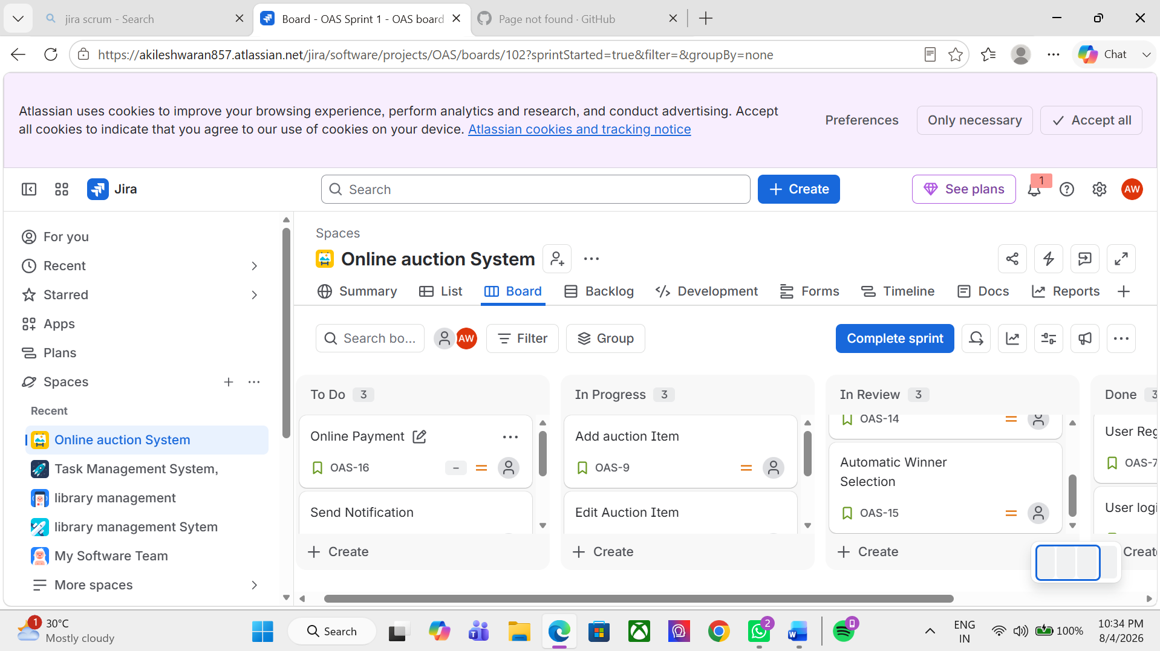

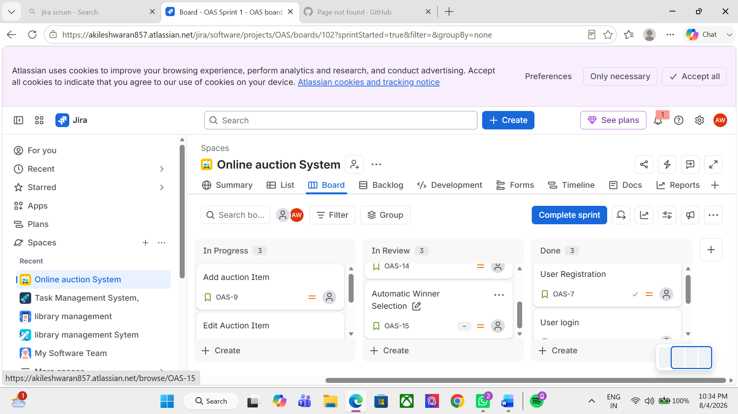

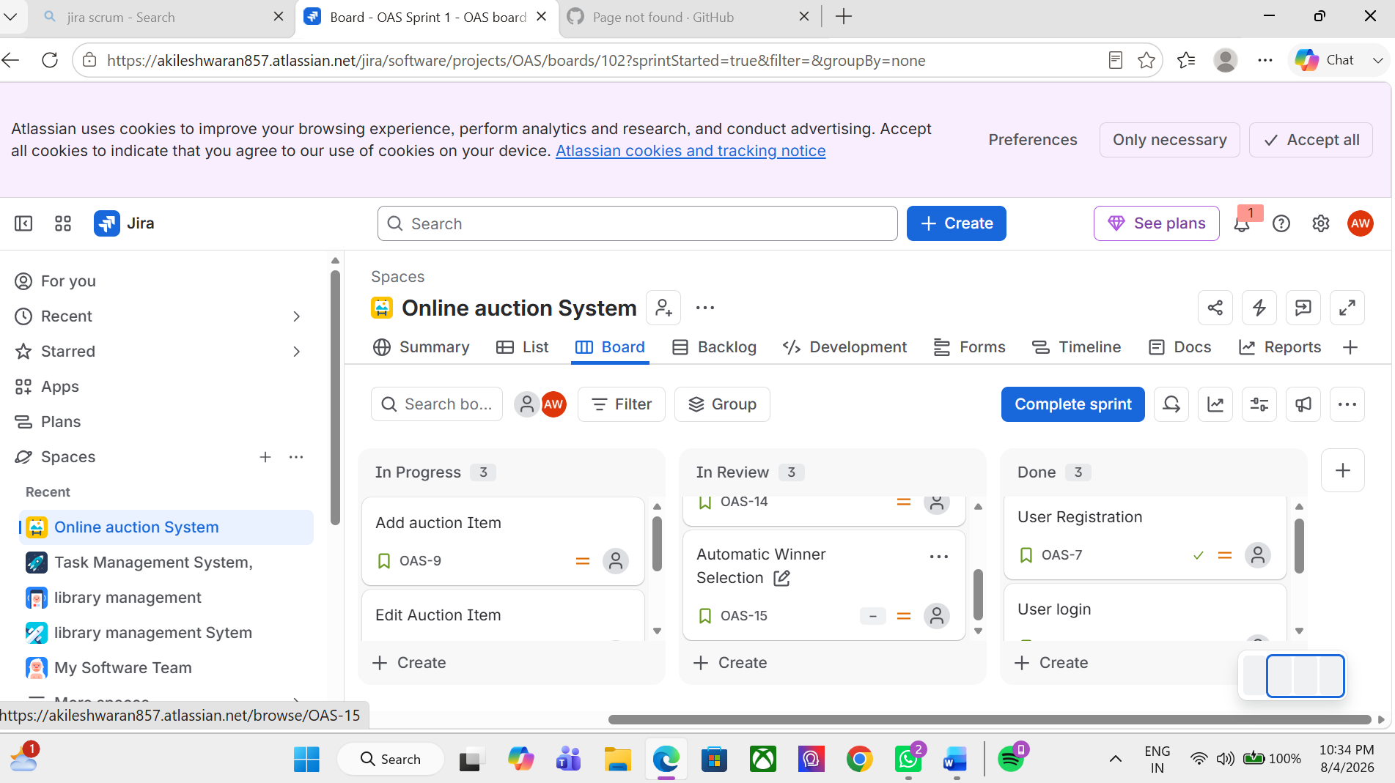

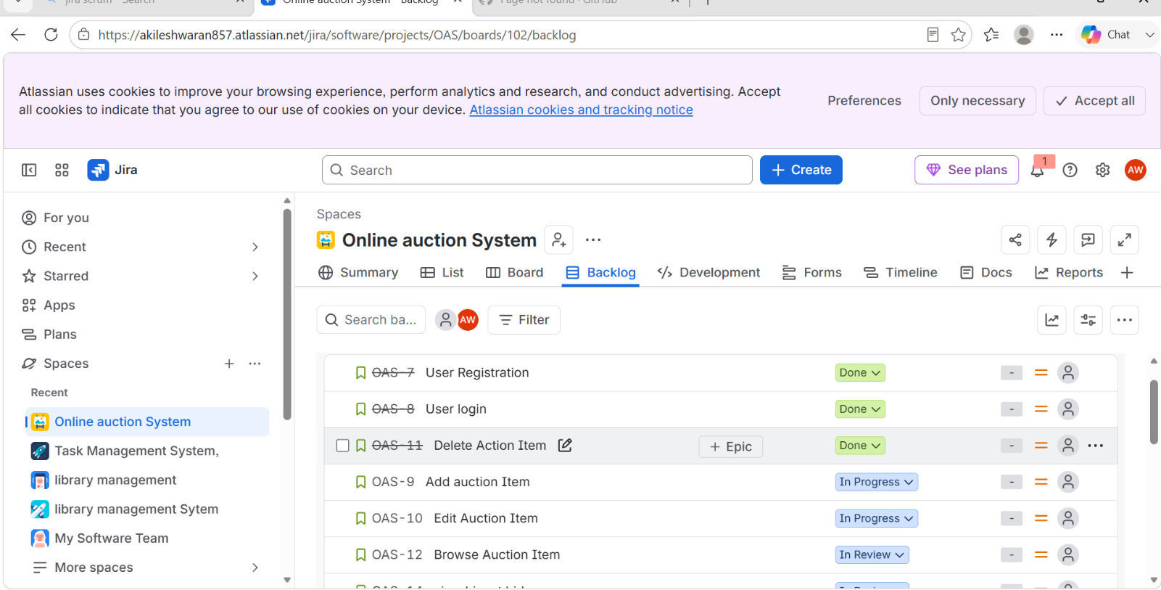

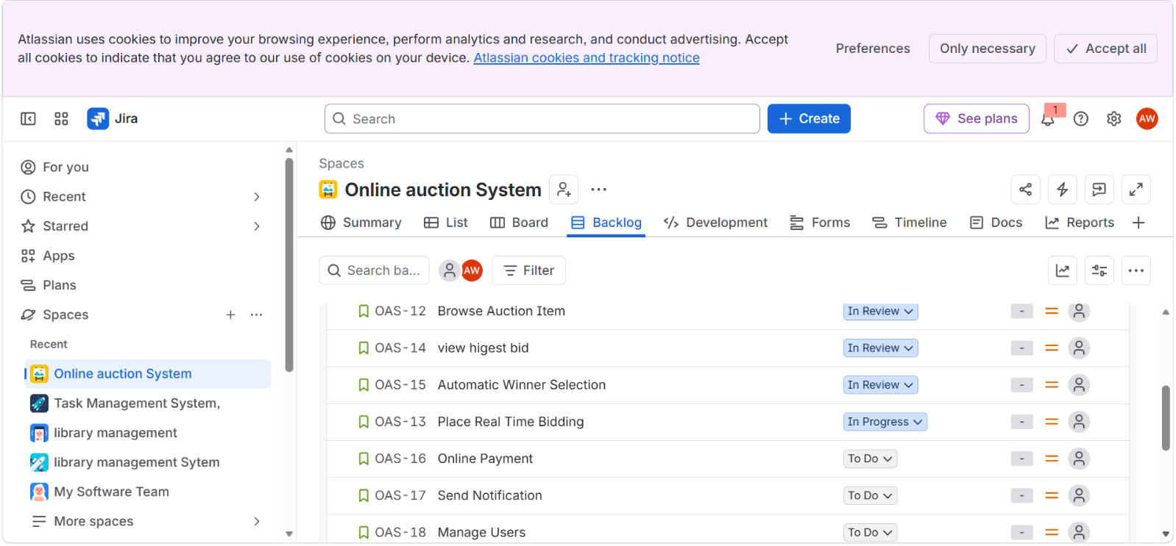

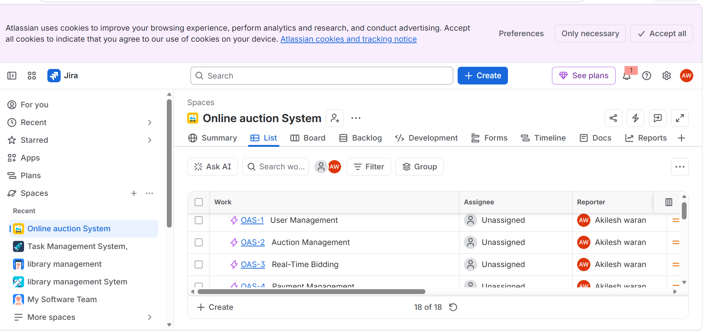

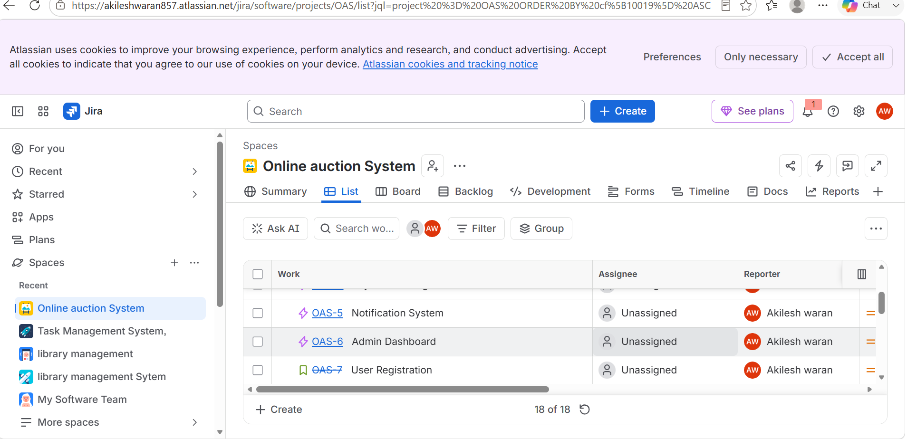

8. Objectives
The primary objective of the Online Auction System with Real-Time Bidding is to develop a secure, reliable, and efficient platform for conducting online auctions. The system aims to simplify the auction process while ensuring fairness, transparency, and user satisfaction.
- The specific objectives of the project are:
- To develop a web-based online auction platform.
- To enable real-time bidding with instant bid updates.
- To provide secure user registration and authentication.
- To allow sellers to create and manage auction listings.
- To enable buyers to participate in live auctions from any location.
- To automatically identify the highest bidder when an auction ends.
- To integrate secure online payment facilities.
- To send instant notifications regarding auction activities.
- To maintain complete auction history and transaction records.
- To provide administrators with tools for monitoring users, products, and auctions.
- To improve transparency, efficiency, and accessibility in the auction process.
- To develop a scalable system capable of supporting multiple simultaneous users.
- To minimize manual work through automation and centralized management.
These objectives ensure that the proposed system meets the requirements of modern online auction platforms while providing a secure and user-friendly experience.

9. Functional Requirements
Functional requirements describe the core operations that the Online Auction System must perform to meet user needs. These features ensure that buyers, sellers, and administrators can interact with the system effectively and complete auction-related activities successfully.
User Registration and Login
The system shall allow new users to create an account by providing their personal details such as name, email address, phone number, and password. Registered users can securely log in using their credentials. Passwords are encrypted to ensure data security.
User Profile Management
Users can update their personal information, change passwords, and manage account settings whenever required. Sellers can also update business information and product details.
Product Listing
Sellers can upload products for auction by entering details such as product name, description, category, images, starting bid amount, reserve price, and auction duration. The system validates product details before publishing the auction.
Auction Management
The system allows sellers to create, edit, and cancel auctions before bidding begins. Administrators can approve or reject auction listings to maintain quality and prevent fraudulent activities.
Real-Time Bidding
Buyers can place bids on active auctions. Every bid is instantly displayed to all participants without refreshing the page. If a higher bid is placed, previous bidders receive immediate updates, ensuring transparency throughout the auction.
Winner Selection
Once the auction time expires, the system automatically closes the auction and identifies the highest bidder as the winner. The winner receives a notification with payment instructions.
Payment Processing
Winning bidders can complete payments through a secure online payment gateway. The system records payment details and updates the transaction status.
Notifications
The system sends notifications for auction start, new highest bid, auction ending, winner announcement, payment confirmation, and order status.
Report Generation
Administrators can generate reports related to users, products, completed auctions, payments, and bidding history for monitoring and analysis.
Overall, these functional requirements ensure that the Online Auction System provides a complete, secure, and efficient auction experience.

10. Non-Functional Requirements

Non-functional requirements define the quality attributes of the Online Auction System. These requirements ensure that the system performs efficiently, securely, and reliably under different operating conditions.
Security
The system must provide secure user authentication, encrypted password storage, protected payment transactions, and role-based access control to prevent unauthorized access.
Performance
The system should respond quickly to user requests and process real-time bids with minimal delay, even when multiple users participate simultaneously.
Reliability
The application should operate continuously without unexpected failures. All auction information and transaction records should be stored accurately to prevent data loss.
Scalability
The system should support an increasing number of users, products, and auctions without affecting overall performance.
Availability
The application should be available 24×7, allowing users to participate in auctions at any time from different locations.
Usability
The user interface should be simple, attractive, and easy to navigate. Even first-time users should be able to use the system without difficulty.
Maintainability
The software should be designed so that future updates, bug fixes, and new features can be implemented easily.
Compatibility
The application should work properly on different web browsers and devices such as desktops, laptops, tablets, and smartphones.

Data Integrity
All user information, bids, payments, and auction records must be stored accurately without duplication or corruption.
These non-functional requirements improve the overall quality, reliability, and user experience of the Online Auction System.

11. Use Case Descriptions
Use Case Descriptions
Use Case 1: User Registration
Actor: Buyer/Seller
Description: New users create an account by entering personal details such as name, email, phone number, and password. After successful registration, users can access the system.
Use Case 2: User Login
Actor: Buyer, Seller, Administrator
Description: Registered users enter their username and password to securely access the system. The system validates credentials before granting access.
Use Case 3: Product Listing
Actor: Seller
Description: Sellers upload products for auction by entering product details, images, starting price, reserve price, and auction duration. The administrator verifies the listing before publication.
Use Case 4: Place Bid
Actor: Buyer
Description: Buyers participate in active auctions by placing bids. Every new bid is displayed instantly to all participants. Users can continue bidding until the auction ends.
Use Case 5: Winner Selection
Actor: System
Description: When the auction timer expires, the system automatically selects the highest bidder and announces the winner. The winner receives payment instructions.
Use Case 6: Payment
Actor: Buyer
Description: The winning bidder completes payment through the secure payment gateway. The system updates the payment status and confirms the transaction.
Use Case 7: Auction Monitoring
Actor: Administrator
Description: The administrator monitors all ongoing auctions, manages users, resolves complaints, and ensures fair bidding practices.
Use Case 8: Report Generation
Actor: Administrator
Description: The administrator generates reports related to users, completed auctions, bidding history, and payment transactions for system monitoring and analysis.
These use case descriptions explain the major interactions between users and the Online Auction System and describe how the system processes each operation.

12. Data Requirements
The Online Auction System with Real-Time Bidding requires a well-structured database to store and manage all information related to users, products, auctions, bids, payments, and system activities. A centralized database ensures that information is stored securely and can be accessed whenever required. Proper data management improves system performance, maintains consistency, and supports real-time updates during the auction process.
The User Table stores registration details such as user ID, name, email address, phone number, password, user role (Buyer, Seller, or Administrator), and account status. This information is used for authentication and user management.
The Product Table contains information about products uploaded by sellers, including product ID, product name, category, description, images, starting bid amount, reserve price, auction start time, auction end time, and seller ID. This enables buyers to view product details before participating in an auction.
The Auction Table maintains auction-specific information such as auction ID, product ID, seller ID, auction status, highest bid amount, highest bidder ID, auction start time, and closing time. This table is updated continuously during the auction process.
The Bid Table records every bid placed by buyers. It includes bid ID, auction ID, bidder ID, bid amount, bid date, and bid time. This information helps maintain complete bidding history and ensures transparency.
The Payment Table stores payment-related information, including payment ID, winner ID, auction ID, payment amount, payment method, payment date, and payment status. Secure payment records help maintain transaction history and financial reporting.
The Notification Table stores messages sent to users, such as bid updates, auction reminders, winner announcements, and payment confirmations. Maintaining notification history improves communication between the system and its users.
Proper database management ensures data accuracy, security, quick retrieval, and efficient operation of the Online Auction System.

13. Requirement Prioritization (MoSCoW)
The MoSCoW prioritization technique is used to classify system requirements based on their importance. It helps developers focus on essential features while planning future enhancements.
Must Have
These are the essential features without which the system cannot function.
User Registration and Login
Seller Product Listing
Auction Creation
Real-Time Bidding
Automatic Winner Selection
Secure Payment Processing
Administrator Dashboard
Database Management
Bid History
Notifications
These features are mandatory for successful implementation of the Online Auction System.
Should Have
These features improve system usability and efficiency but are not absolutely essential.
Product Search and Filters
Auction Reports
Email Notifications
Seller Dashboard
Buyer Dashboard
User Profile Management
Auction History
Feedback System
These requirements enhance user experience and improve system functionality.
Could Have
These are optional features that can be implemented in future versions.
AI-Based Bid Recommendation
Product Recommendation System
Mobile Application
Live Chat Support
Dark Mode
Multi-language Support
QR Code Payment
These features increase user convenience but are not necessary for the first release.
Won't Have (Current Version)
The following features are excluded from the current version due to time and project scope limitations.
Cryptocurrency Payments
Blockchain-Based Auctions
Voice-Controlled Bidding
Virtual Reality Auction Rooms
International Currency Conversion
These features may be considered for future development.

14. Future Enhancements
Although the proposed Online Auction System provides all essential auction functionalities, several advanced features can be added in future versions to improve system performance and user experience.
Artificial Intelligence can be integrated to recommend suitable products based on user interests and previous bidding history. Machine learning algorithms can also predict bidding trends and suggest optimal bidding strategies.
A dedicated mobile application for Android and iOS devices can increase accessibility and allow users to participate in auctions from anywhere.
Blockchain technology can be incorporated to improve security and transparency by maintaining tamper-proof bidding records and transaction histories.
The system can support multiple languages and international currencies to enable users from different countries to participate in auctions.
Advanced notification systems using SMS, email, and mobile push notifications can improve user engagement by providing instant updates regarding auction activities.
Live video streaming can allow sellers to demonstrate products during auctions, increasing buyer confidence and product transparency.
Voice-assisted bidding, biometric authentication, AI-powered fraud detection, and cloud-based scalability can also be incorporated to improve security, reliability, and performance.
These enhancements will make the Online Auction System more intelligent, secure, scalable, and suitable for large-scale commercial applications.

15. Conclusion
Online Auction System with Real-Time Bidding is an efficient web-based platform that modernizes the traditional auction process by enabling buyers and sellers to participate in auctions from any location. The system provides real-time bid updates, secure authentication, automatic winner selection, online payment integration, and centralized database management, ensuring transparency and fairness throughout the auction process.
The proposed system overcomes the limitations of conventional auction methods by eliminating geographical restrictions, reducing manual effort, and improving communication between users through instant notifications. The administrator module simplifies system management by providing tools to monitor auctions, manage users, generate reports, and resolve disputes efficiently.
By implementing real-time bidding technology, the system enhances user participation and creates a competitive auction environment where every participant has equal access to the latest bidding information. Secure payment processing and data protection mechanisms further increase user trust and system reliability.
Overall, the Online Auction System with Real-Time Bidding is a practical, secure, and scalable solution for conducting online auctions. It improves operational efficiency, enhances customer satisfaction, and supports the growing demand for digital commerce. With future enhancements such as artificial intelligence, blockchain integration, and mobile applications, the system can evolve into a comprehensive online auction platform capable of serving a large number of users across different industries

